**POWER BI and SQL Project**

**1. KPIs**

**a. Total revenue**:select sum(total_price) as Total_Price from pizza_sales ;

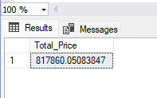

**b. Average Order Value**: select sum(total_price)/count(distinct order_id) as Avg_Order_Value from pizza_sales;

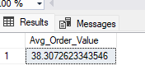

**c. Total Pizzas Sold:** select sum(quantity) as Total_pizzas_sold from pizza_sales;

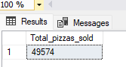

**d. Total orders:** select count(distinct order_id) Total_Orders from pizza_sales;

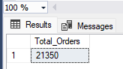

**e. Average Pizzas per order:** select cast(cast(sum(quantity) as decimal(10,2))/cast(count(distinct order_id)as decimal(10,2)) as decimal(10,2)) as Average_pizzas_per_order from pizza_sales;

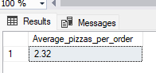

**2. Chart Requirements**

**a. Daily Trends:** select datename(dw,order_date) as Order_day, count(distinct order_id) as Total_order from pizza_sales group by datename(dw,order_date);

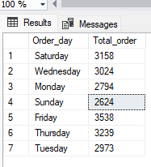

**b. Monthly Trends:** select datename(month,order_date) as Order_Month, count(distinct order_id) as Total_Orders from pizza_sales group by datename(month,order_date);

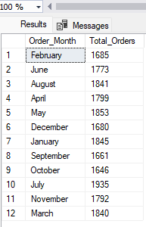

**c. Percentage of sales by pizza category:** select pizza_category, sum(total_price)*100/(select sum(total_price) from pizza_sales) as Total_Sales from pizza_sales group by pizza_category;

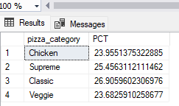

**d. Filtering data on basis of months:** select pizza_category, sum(total_price)*100/(select sum(total_price) from pizza_sales where month(order_date)=1) as PCT from pizza_sales where month(order_date)=1 group by pizza_category;

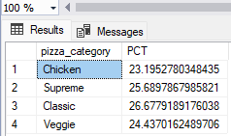

**e. Percentage of sales by pizza size:** select pizza_size, sum(total_price) as Total_Price , sum(total_price)*100/(select sum(total_price) from pizza_sales ) as PCT from pizza_sales

group by pizza_size;

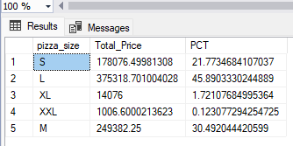

**f. Top 5 pizzas by Revenue:** select top 5 pizza_name, sum(total_price) as Revenue from pizza_sales group by pizza_name order by Revenue desc;

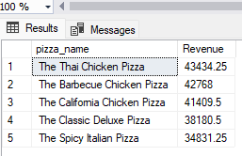

**g. Bottom 5 pizzas by Revenue:** select top 5 pizza_name, sum(total_price) as Revenue from pizza_sales group by pizza_name order by Revenue;

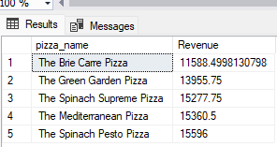

**h. Top 5 pizzas by Quantity:** select top 5 pizza_name, sum(quantity) as Total_Quantity from pizza_sales group by pizza_name order by Total_Quantity DESC;

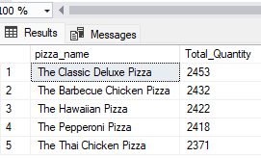

**i. Bottom 5 pizzas by Quantity:** select top 5 pizza_name, sum(quantity) as Total_Quantity from pizza_sales group by pizza_name order by Total_Quantity;

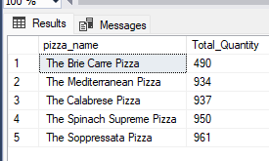

**j.Top 5 pizzas by Order:** select top 5 pizza_name, count(distinct order_id) as Total_Order from pizza_sales group by pizza_name order by Total_Order desc;

